**Kubernetes Installation Guideline**

**Step 1 –**

$ sudo su

# apt-get update

### Step 2 – Turn Off Swap Space

# swapoff -a

# nano /etc/fstab

### Step 3 – **Update The Hostnames**

# vi /etc/hostname

### Press (i) for insert mode and update the hostname and for saving the file use (Esc) -> (:wq!) -> (Enter)

### Change the hostname to any of your choice. Example – kmaster

### Restart the system.

### Step 4 – **Update The Hosts File With IPs Of Master & Node**

### Run the following command on both machines to note the IP addresses of each.

# ifconfig

### Now keep a note of ip address. Now go to the ‘hosts’ file on both master and node and add an entry specifying their respective ip addresses with their host names (Example – ‘kmaster’,’knode’). This is used for referencing them in the cluster.

# vi /etc/hosts

### /eyc/hosts file - install kubernetes - edureka

### Press (i) for insert mode and add the ip address, hostname and for saving the file use (Esc) -> (:wq!) -> (Enter)

### Step 5 – Install Kubernetes

### Installing the Kubernetes Environment

# apt-get update && apt-get install -y apt-transport-https curl

# curl -s https://packages.cloud.google.com/apt/doc/apt-key.gpg | apt-key add -

# cat <<EOF >/etc/apt/sources.list.d/kubernetes.list

deb http://apt.kubernetes.io/ kubernetes-xenial main

EOF

# apt-get update

### Now install kubeadm, kubelet, kubectl

# apt-get install -y kubelet kubeadm kubectl

### Restart the system.

### Configure kubelet(Optional)

# kubeadm reset

# swapoff –a

### Now, remove swap entry from

# vi /etc/fstab

### Press (i) for insert mode and remove the swap entry and for saving the file use (Esc)->(:wq!)-(Enter)

# systemctl daemon-reload

# systemctl restart kubelet

### And now check the kubelet running status

# systemctl status kubelet

# journalctl –xeu kubelet

**Step 6 –**

Initializing the cluster

# kubeadm init –-pod-network-cidr=10.244.0.0/16 –apiserver-advertise-address=10.11.14.76

Now run below commands **without root user**

$ mkdir –p $HOME/.kube

$ sudo cp –i /etc/kubernetes/admin.confi $HOME/.kube/config

$ sudo chown $(id -u):$(id -g) $HOME/.kube/config

*Now install the pod network add-on

Disable ipv6 on all the nodes

$ sudo vi /etc/sysctl.conf

### Press (i) for insert mode and add below line at bottom and for saving the file use (Esc) -> (:wq!) -> (Enter)

net.ipv6.conf.all.disable_ipv6 = 1

net.ipv6.conf.default.disable_ipv6 = 1

net.ipv6.conf.lo.disable_ipv6 = 1

Then execute the below command

$ sysctl -p

After that ,run

$ cat /proc/sys/net/ipv6/conf/all/disable_ipv6

If it return **1** then ipv6 has been successfully disabled.

Now add the network add on for Flannel

$ kubectl apply -f https://raw.githubusercontent.com/coreos/flannel/master/Documentation/kube-flannel.yml

**Step 7 –**

Installation of Dashboard

$ kubectl create -f https://raw.githubusercontent.com/kubernetes/dashboard/master/src/deploy/recommended/kubernetes-dashboard.yaml

**Step 8 –**

Run the following command for accessing the dashboard in browser

$ kubectl proxy

Now go to browser and access the dashboard

<http://localhost:8001/api/v1/namespaces/kube-system/services/https:kubernetes-dashboard:/proxy/>

**Step 9 –**

In this step, we will create the service account for the dashboard and get it’s credentials.

(Note : Run all these commands in a new terminal)

$ kubectl create serviceaccount dashboard -n default

$ kubectl create clusterrolebinding dashboard-admin -n default \

--clusterrole=cluster-admin \

--serviceaccount=default:dashboard

*And now this command will give you the token required for your dashboard login

$ kubectl get secret $(kubectl get serviceaccount dashboard -o jsonpath="{.secrets[0].name}") -o jsonpath="{.data.token}" | base64 --decode

Copy the token and paste it in Dashboard Login Page, by selecting the token option. And you will be successfully get loged-in.

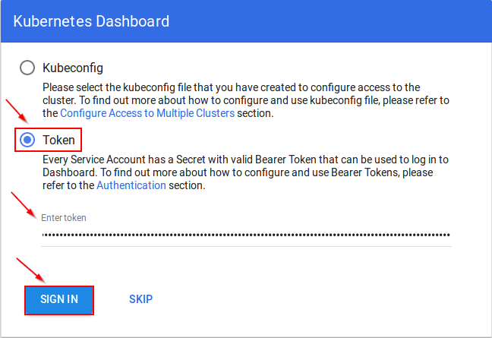

**Step 10 –**

Now on **node machine**, to join the cluster created by the master node use below command to join.

$ sudo kubeadm join --apiserver-advertise-address=<ip-address-of-the master> --pod-network-cidr=10.244.0.0/16